**Git & GitHub Assignment 2 – Section 1,2,3,4**

**Questions:**

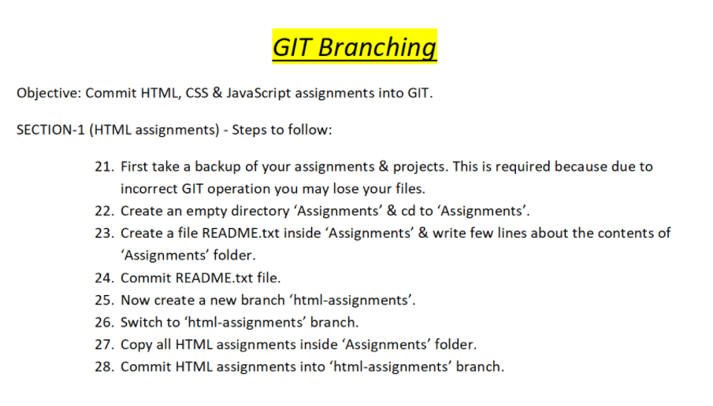

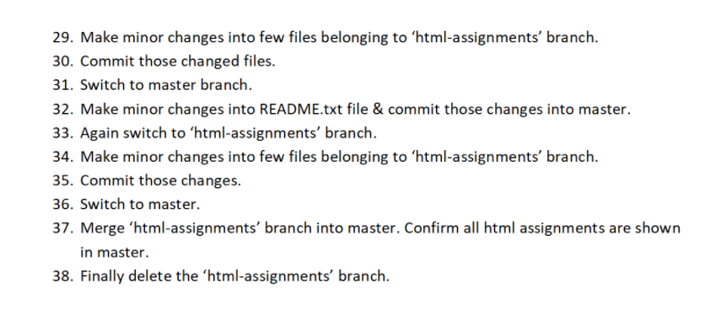

**Comments & Results**

**$ pwd**

/c/Users/jeyas

$ cd C:/Users/jeyas/Desktop/Assignments

**$ git init**

Initialized empty Git repository in C:/Users/jeyas/Desktop/Assignments/.git/

**$ git add README.txt**

**$ git commit -m"first file"**

[master (root-commit) 44288a0] first file

1 file changed, 1 insertion(+)

create mode 100644 README.txt

**$ git branch html-assignments**

**$ git status**

On branch master

nothing to commit, working tree clean

**$ git branch**

html-assignments

* master

**$ git checkout html-assignments**

Switched to branch 'html-assignments'

**$ touch new.html**

**$ git add new.html**

**$ git commit -m "second html file"**

[html-assignments a683a01] second html file

1 file changed, 0 insertions(+), 0 deletions(-)

create mode 100644 new.html

**$ git status**

On branch html-assignments

nothing to commit, working tree clean

**$ graph**

* a683a01 (HEAD -> html-assignments) second html file

* 44288a0 (master) first file

**$ git status**

On branch html-assignments

Changes not staged for commit:

(use "git add <file>..." to update what will be committed)

(use "git restore <file>..." to discard changes in working directory)

modified: README.txt

modified: new.html

no changes added to commit (use "git add" and/or "git commit -a")

**$ git add new.html**

**$ git commit -m"chnage 1"**

[html-assignments c35ab38] chnage 1

1 file changed, 1 insertion(+)

**$ git add README.txt**

$ git commit -m"change tqo"

[html-assignments 0012cff] change tqo

1 file changed, 2 insertions(+), 1 deletion(-)

$ git checkout master

Switched to branch 'master'

**$ graph**

* 0012cff (html-assignments) change tqo

* c35ab38 chnage 1

* a683a01 second html file

* 44288a0 (HEAD -> master) first file

**$ git checkout html-assignments**

Switched to branch 'html-assignments'

**$ git checkout master**

Switched to branch 'master'

**$ git status**

On branch master

Changes not staged for commit:

(use "git add <file>..." to update what will be committed)

(use "git restore <file>..." to discard changes in working directory)

modified: README.txt

no changes added to commit (use "git add" and/or "git commit -a")

**$ git add README.txt**

**$ git commit -m"third change"**

[master 93061cd] third change

1 file changed, 3 insertions(+), 1 deletion(-)

**$ git checkout html-assignments**

Switched to branch 'html-assignments'

**$ git status**

On branch html-assignments

Changes not staged for commit:

(use "git add <file>..." to update what will be committed)

(use "git restore <file>..." to discard changes in working directory)

modified: README.txt

modified: new.html

no changes added to commit (use "git add" and/or "git commit -a")

**$ git add README.txt**

**$ git commit -m"4th change"**

[html-assignments 078db53] 4th change

1 file changed, 3 insertions(+), 1 deletion(-)

**$ git add new.html**

**$ git commit -m"fourth change"**

[html-assignments 875eea8] fourth change

1 file changed, 3 insertions(+), 1 deletion(-)

**$ git status**

On branch html-assignments

nothing to commit, working tree clean

**$ graph**

* 875eea8 (HEAD -> html-assignments) fourth change

* 078db53 4th change

* 0012cff change tqo

* c35ab38 chnage 1

* a683a01 second html file

| * 93061cd (master) third change

|/

* 44288a0 first file

**$ git branch**

* html-assignments

master

**$ graph**

* 875eea8 (HEAD -> html-assignments) fourth change

* 078db53 4th change

* 0012cff change tqo

* c35ab38 chnage 1

* a683a01 second html file

| * 93061cd (master) third change

|/

* 44288a0 first file

**$ git checkout master**

Switched to branch 'master'

**$ git diff master..html-assignments**

diff --git a/README.txt b/README.txt

index 5fa5a0c..a193c7d 100644

--- a/README.txt

+++ b/README.txt

@@ -1,3 +1,4 @@

ADA PONGADA

+mudilaya

-enadaaaaaaa

\ No newline at end of file

+over over

\ No newline at end of file

diff --git a/new.html b/new.html

new file mode 100644

index 0000000..5791b97

--- /dev/null

+++ b/new.html

@@ -0,0 +1,3 @@

+helllo world

+

+nalladhu

\ No newline at end of file

**$ git merge html-assignments**

Auto-merging README.txt

CONFLICT (content): Merge conflict in README.txt

Automatic merge failed; fix conflicts and then commit the result.

**$ git status**

On branch master

You have unmerged paths.

(fix conflicts and run "git commit")

(use "git merge --abort" to abort the merge)

Changes to be committed:

new file: new.html

Unmerged paths:

(use "git add <file>..." to mark resolution)

both modified: README.txt

**$ git add README.txt**

**$ git commit -m"merge solve"**

[master 55e1657] merge solve

**$ git status**

On branch master

nothing to commit, working tree clean

**$ git merge html-assignments**

Already up to date.

**$ graph**

* 55e1657 (HEAD -> master) merge solve

|\

| * 875eea8 (html-assignments) fourth change

| * 078db53 4th change

| * 0012cff change tqo

| * c35ab38 chnage 1

| * a683a01 second html file

* | 93061cd third change

|/

* 44288a0 first file

**$ git checkout html-assignments**

Switched to branch 'html-assignments'

**$ git checkout master**

Switched to branch 'master'

**$ git branch -d html-assignments**

Deleted branch html-assignments (was 875eea8).

**$ git status**

On branch master

nothing to commit, working tree clean

**$ git branch**

* master

**$ graph**

* 55e1657 (HEAD -> master) merge solve

|\

| * 875eea8 fourth change

| * 078db53 4th change

| * 0012cff change tqo

| * c35ab38 chnage 1

| * a683a01 second html file

* | 93061cd third change

|/

* 44288a0 first file

**$ git status**

On branch master

Changes not staged for commit:

(use "git add <file>..." to update what will be committed)

(use "git restore <file>..." to discard changes in working directory)

modified: README.txt

no changes added to commit (use "git add" and/or "git commit -a")

**$ git add README.txt**

**$ git commit -m"final commit"**

[master 8cdb975] final commit

1 file changed, 3 insertions(+), 3 deletions(-)

**$ git remote add origin https://github.com/Jai41055/branching.git**

**$ git push -u origin master**

Enumerating objects: 27, done.

Counting objects: 100% (27/27), done.

Delta compression using up to 8 threads

Compressing objects: 100% (17/17), done.

Writing objects: 100% (27/27), 2.28 KiB | 101.00 KiB/s, done.

Total 27 (delta 1), reused 0 (delta 0), pack-reused 0

remote: Resolving deltas: 100% (1/1), done.

To https://github.com/Jai41055/branching.git

* [new branch] master -> master

Branch 'master' set up to track remote branch 'master' from 'origin'.

**Questions:**

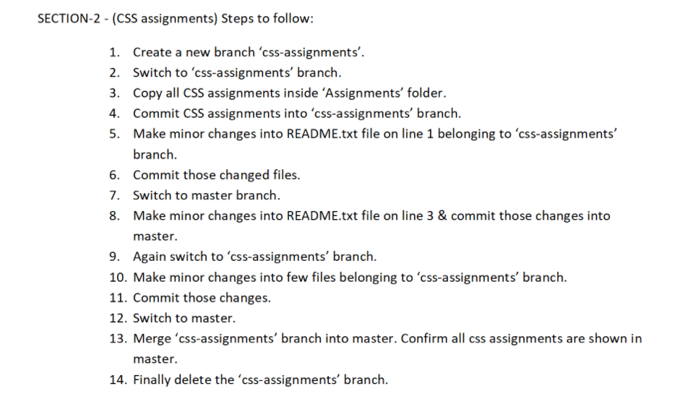

**Comments & Results**

**$ git branch css-assignments**

**$ git status**

On branch master

Your branch is up to date with 'origin/master'.

nothing to commit, working tree clean

**$ git branch**

css-assignments

* master

**$ graph**

* 8cdb975 (HEAD -> master, origin/master, css-assignments) final commit

* 55e1657 merge solve

|\

| * 875eea8 fourth change

| * 078db53 4th change

| * 0012cff change tqo

| * c35ab38 chnage 1

| * a683a01 second html file

* | 93061cd third change

|/

* 44288a0 first file

**$ git checkout css-assignments**

Switched to branch 'css-assignments'

**$ touch new.css**

**$ git add new.css**

**$ git commit -m" css1"**

[css-assignments 4f1d26b] css1

1 file changed, 0 insertions(+), 0 deletions(-)

create mode 100644 new.css

**$ git status**

On branch css-assignments

nothing to commit, working tree clean

**$ git checkout master**

Switched to branch 'master'

Your branch is up to date with 'origin/master'.

**$ git checkout css-assignments**

Switched to branch 'css-assignments'

**$ git status**

On branch css-assignments

Changes not staged for commit:

(use "git add <file>..." to update what will be committed)

(use "git restore <file>..." to discard changes in working directory)

modified: README.txt

no changes added to commit (use "git add" and/or "git commit -a")

**$ git add README.txt**

**$ git commit -m "css2"**

[css-assignments a58f5e8] css2

1 file changed, 1 insertion(+)

**$ git checkout master**

Switched to branch 'master'

Your branch is up to date with 'origin/master'.

**$ git status**

On branch master

Your branch is up to date with 'origin/master'.

Changes not staged for commit:

(use "git add <file>..." to update what will be committed)

(use "git restore <file>..." to discard changes in working directory)

modified: README.txt

no changes added to commit (use "git add" and/or "git commit -a")

**$ git add README.txt**

**$ git commit -m"css3"**

[master 85fd334] css3

1 file changed, 1 insertion(+)

**$ git checkout css-assignments**

Switched to branch 'css-assignments'

**$ git status**

On branch css-assignments

Changes not staged for commit:

(use "git add <file>..." to update what will be committed)

(use "git restore <file>..." to discard changes in working directory)

modified: README.txt

modified: new.css

modified: new.html

no changes added to commit (use "git add" and/or "git commit -a")

**$ git add README.txt**

**$ git commit -m"css4"**

[css-assignments d36dd84] css4

1 file changed, 2 insertions(+), 1 deletion(-)

**$ git add new.css**

**$ git commit -m"css5"**

[css-assignments 1b86f10] css5

1 file changed, 1

**$ git add new.html**

**$ git commit -m"css6"**

[css-assignments 778f511] css6

1 file changed, 2 insertions(+), 1 deletion(-)

**$ git status**

On branch css-assignments

nothing to commit, working tree clean

**$ git checkout master**

Switched to branch 'master'

Your branch is ahead of 'origin/master' by 1 commit.

(use "git push" to publish your local commits)

**$ git merge css-assignments**

Auto-merging README.txt

Merge made by the 'recursive' strategy.

README.txt | 2 ++

new.css | 1 +

new.html | 3 ++-

3 files changed, 5 insertions(+), 1 deletion(-)

create mode 100644 new.css

**$ git branch**

css-assignments

* master

**$ git status**

On branch master

Your branch is ahead of 'origin/master' by 7 commits.

(use "git push" to publish your local commits)

nothing to commit, working tree clean

**$ git branch -d css-assignments**

Deleted branch css-assignments (was 778f511).

**$ git branch**

* master

**$ graph**

* 9aebb11 (HEAD -> master) Merge branch 'css-assignments'

|\

| * 778f511 css6

| * 1b86f10 css5

| * d36dd84 css4

| * a58f5e8 css2

| * 4f1d26b css1

* | 85fd334 css3

|/

* 8cdb975 (origin/master) final commit

* 55e1657 merge solve

|\

| * 875eea8 fourth change

| * 078db53 4th change

| * 0012cff change tqo

| * c35ab38 chnage 1

| * a683a01 second html file

* | 93061cd third change

|/

* 44288a0 first file

**$ git remote add origin https://github.com/Jai41055/css-assignmnets.git**

**$ git push**

Enumerating objects: 24, done.

Counting objects: 100% (24/24), done.

Delta compression using up to 8 threads

Compressing objects: 100% (18/18), done.

Writing objects: 100% (21/21), 1.92 KiB | 85.00 KiB/s, done.

Total 21 (delta 5), reused 0 (delta 0), pack-reused 0

remote: Resolving deltas: 100% (5/5), done.

To https://github.com/Jai41055/branching.git

8cdb975..9aebb11 master -> master

**Questions:**

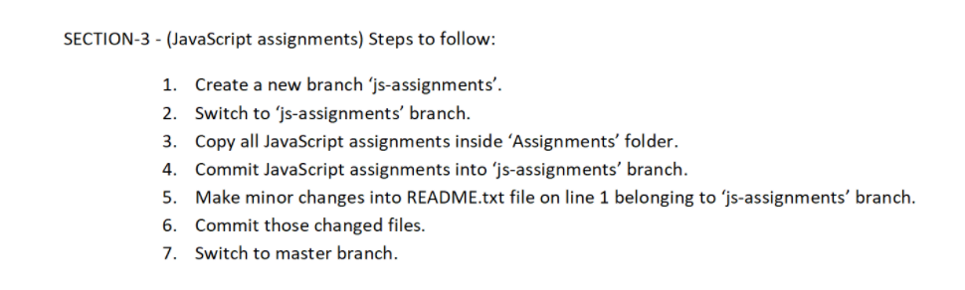

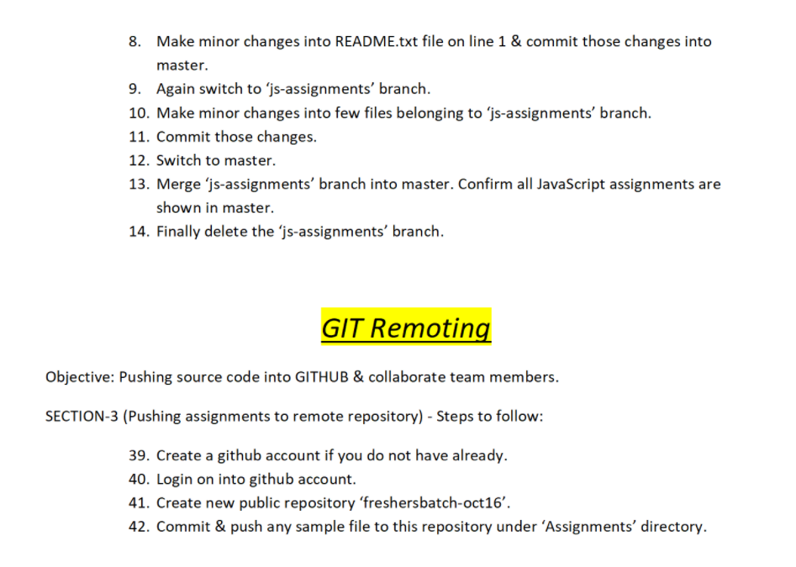

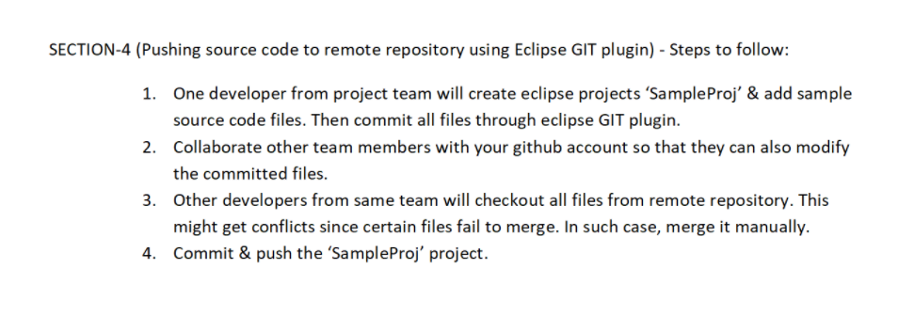

**Comments & Results:**

**$ git branch js-assignments**

**$ git checkout js-assignments**

Switched to branch 'js-assignments'

**$ touch final.js**

**$ git add final.js**

**$ git commit -m"change1"**

[js-assignments 9ee565f] change1

1 file changed, 0 insertions(+), 0 deletions(-)

create mode 100644 final.js

**$ git status**

On branch js-assignments

Changes not staged for commit:

(use "git add <file>..." to update what will be committed)

(use "git restore <file>..." to discard changes in working directory)

modified: README.txt

no changes added to commit (use "git add" and/or "git commit -a")

**$ git add README.txt**

**$ git commit -m"change 2 on line 1"**

[js-assignments a3586dc] change 2 on line 1

1 file changed, 1 insertion(+), 1 deletion(-)

**$ git checkout master**

Switched to branch 'master'

Your branch is up to date with 'origin/master'.

**$ git status**

On branch master

Your branch is up to date with 'origin/master'.

Changes not staged for commit:

(use "git add <file>..." to update what will be committed)

(use "git restore <file>..." to discard changes in working directory)

modified: README.txt

no changes added to commit (use "git add" and/or "git commit -a")

**$ git add README.txt**

**$ git commit -m"change 3 on line 1"**

[master 8dc44ae] change 3 on line 1

1 file changed, 1 insertion(+), 1 deletion(-)

**$ git status**

On branch master

Your branch is ahead of 'origin/master' by 1 commit.

(use "git push" to publish your local commits)

nothing to commit, working tree clean

**$ git status**

On branch master

Your branch is ahead of 'origin/master' by 1 commit.

(use "git push" to publish your local commits)

nothing to commit, working tree clean

**$ git checkout js-assignments**

Switched to branch 'js-assignments'

**$ git status**

On branch js-assignments

Changes not staged for commit:

(use "git add <file>..." to update what will be committed)

(use "git restore <file>..." to discard changes in working directory)

modified: README.txt

modified: final.js

modified: new.css

modified: new.html

no changes added to commit (use "git add" and/or "git commit -a")

**$ git commit -m"change 5 on text"**

On branch js-assignments

Changes not staged for commit:

(use "git add <file>..." to update what will be committed)

(use "git restore <file>..." to discard changes in working directory)

modified: README.txt

modified: final.js

modified: new.css

modified: new.html

no changes added to commit (use "git add" and/or "git commit -a")

**$ git add README.txt**

**$ git commit -m"change 5 on text"**

[js-assignments 270fab6] change 5 on text

1 file changed, 2 insertions(+), 1 deletion(-)

**$ git add new.html**

**$ git commit -m"chnge6 on html"**

[js-assignments 9e0a036] chnge6 on html

1 file changed, 2 insertions(+), 1 deletion(-)

**$ git add new.css**

**$ git commit -m"chnge 7 on css"**

[js-assignments ce48588] chnge 7 on css

1 file changed, 2 insertions(+), 1 deletion(-)

**$ git add final.js**

**$ git commit -m"chanh7 on js"**

[js-assignments 7f5ad8e] chanh7 on js

1 file changed, 1 insertion(+)

**$ git checkout master**

Switched to branch 'master'

Your branch is ahead of 'origin/master' by 1 commit.

(use "git push" to publish your local commits)

**$ git checkout master**

Already on 'master'

Your branch is ahead of 'origin/master' by 1 commit.

(use "git push" to publish your local commits)

**$ git merge js-assignments**

Auto-merging README.txt

CONFLICT (content): Merge conflict in README.txt

Automatic merge failed; fix conflicts and then commit the result.

**$ git status**

On branch master

Your branch is ahead of 'origin/master' by 1 commit.

(use "git push" to publish your local commits)

You have unmerged paths.

(fix conflicts and run "git commit")

(use "git merge --abort" to abort the merge)

Changes to be committed:

new file: final.js

modified: new.css

modified: new.html

Unmerged paths:

(use "git add <file>..." to mark resolution)

both modified: README.txt

**$ git add README.txt**

**$ git commit -m"final merge"**

[master 42909c9] final merge

**$ graph**

* 42909c9 (HEAD -> master) final merge

|\

| * 7f5ad8e (js-assignments) chanh7 on js

| * ce48588 chnge 7 on css

| * 9e0a036 chnge6 on html

| * 270fab6 change 5 on text

| * a3586dc change 2 on line 1

| * 9ee565f change1

* | 8dc44ae change 3 on line 1

|/

* 9aebb11 (origin/master) Merge branch 'css-assignments'

|\

| * 778f511 css6

| * 1b86f10 css5

| * d36dd84 css4

| * a58f5e8 css2

| * 4f1d26b css1

* | 85fd334 css3

|/

* 8cdb975 final commit

* 55e1657 merge solve

|\

| * 875eea8 fourth change

| * 078db53 4th change

| * 0012cff change tqo

| * c35ab38 chnage 1

| * a683a01 second html file

* | 93061cd third change

|/

* 44288a0 first file

**$ git branch**

js-assignments

* master

**$ git branch -d js-assignments**

Deleted branch js-assignments (was 7f5ad8e).

**$ git branch**

* master

**$ git status**

On branch master

Your branch is ahead of 'origin/master' by 8 commits.

(use "git push" to publish your local commits)

Changes not staged for commit:

(use "git add <file>..." to update what will be committed)

(use "git restore <file>..." to discard changes in working directory)

modified: README.txt

modified: new.html

no changes added to commit (use "git add" and/or "git commit -a")

**$ git add README.txt**

**$ git commit -m"final allignment text"**

[master 71cf6bb] final allignment text

1 file changed, 8 deletions(-)

**$ git add new.html**

**$ git commit -m"final allignment html"**

[master 1de3284] final allignment html

1 file changed, 1 deletion(-)

**$ git push**

Enumerating objects: 34, done.

Counting objects: 100% (34/34), done.

Delta compression using up to 8 threads

Compressing objects: 100% (27/27), done.

Writing objects: 100% (30/30), 3.09 KiB | 143.00 KiB/s, done.

Total 30 (delta 7), reused 0 (delta 0), pack-reused 0

remote: Resolving deltas: 100% (7/7), done.

To https://github.com/Jai41055/branching.git

9aebb11..1de3284 master -> master

**$ git remote set-url origin https://github.com/Jai41055/the-entire-one.git**

**$ git push**

Enumerating objects: 76, done.

Counting objects: 100% (76/76), done.

Delta compression using up to 8 threads

Compressing objects: 100% (62/62), done.

Writing objects: 100% (76/76), 7.12 KiB | 331.00 KiB/s, done.

Total 76 (delta 14), reused 0 (delta 0), pack-reused 0

remote: Resolving deltas: 100% (14/14), done.

To https://github.com/Jai41055/the-entire-one.git

* [new branch] master -> master